**C768, Task 1**

**Jordan A Brewer**

**Western Governors University**

Table of Contents

A. Internal Communication Artifact 4

B. Fact Sheet Artifact 5

C. Writing Process Analysis for Each Artifact 6

D. Audience Analysis for Each Artifact 7

E. Sources 8

# Internal Communication Artifact

**Subject:** Proposal to Incorporate a Virtual Private Network Throughout the Company

**Date:** Thurs 7 May 2020 8:33AM

**From:** Jordan A. Brewer <jordan.brewer@seamusco.com>

**To:** sarah.wilburn@seamusco.com

Dear Mrs. Wilburn and Review Council:

The internet is a web of information when used responsibly can help us achieve great things. Unfortunately, some choose to use the internet for more nefarious means. Mr. Sousa has tasked the I.T. department in further protecting our network from such threats. I am Jordan Brewer and am the lead security annalist within the I.T. Department. The resource my colleagues and I have chosen to further protect our network is by applying a VPN, a Virtual Privet Network.

A VPN is essentially a secure tunnel through the internet from an employee’s PC to the internal network. This is achieved by encrypting any data sent or received by the employee. As employees achieve their daily jobs, this will increase the security of our proprietary data. Security isn’t the only benefit, utilizing a VPN will allow employees access to the company internal network from remote locations allowing for employees to work from home or on the go, securely.

The I.T. employees and I have selected Cisco AnyConnect Secure Mobility Client as the VPN service we will utilize. Cisco is the leader in networking hardware. Cisco AnyConnect is fully scalable to ensure all the necessary employees have access to its features.

Cisco AnyConnect offers comprehensive protection to defend against threats regardless of where they are. Cisco Identity Services Engine (ISE) prevents unauthorized devices from accessing the network and with Duo Two Factor Authentication (MFA) to verify user identities, we can ensure only those authorized have access to our internal resources.

The competitive pricing Cisco offers makes it an ideal candidate for our networking needs. Licensing packages make implementation for our business affordable, with packages starting at $4,998/yr. with competitors pricing costing 6,000+/yr.

Sincerely,

Jordan Brewer

# Fact Sheet Artifact

**Why Use a VPN?**

VPN

Consider this you are at a coffee shop and connect to the public WIFI. Pretty standard practice. But do you know who might be watching the traffic on that network? Enter the VPN (Virtual Privet Network). Without a VPN your data is your browsing activities are open to prying eyes of those who could use the information for nefarious means. As a company we are constantly looking to improve upon the protection of our proprietary data and to ensure we are utilizing the best security measures to do so.

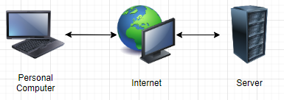

Figure :Traditional network

A VPN protects data from unauthorized eyes and other intrusions by creating a secure encrypted connection through the internet from your personal computer to the corporate internal servers ensuring only you are the one utilizing the connection.

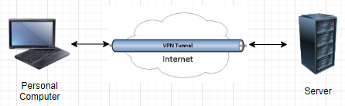

Figure :Example of a VPN protected network

**Cisco AnyConnect**

Cisco AnyConnect is the leading VPN solution utilizing. AnyConnect employees can access the internal network wherever they are. Additionally, Cisco AnyConnect will give the option of working from home for those of us whom are able to do so on occasion. Speak with your manager if this is something you might be interested in.

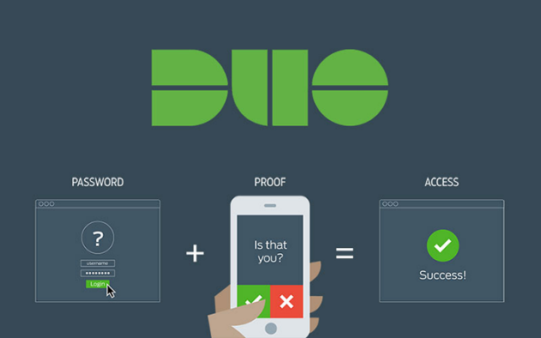

Figure :Duo Authentication

**Duo Authentication**

Duo Authentication is a 2 Factor Authentication system ensuring that only those authorized have access to our internal network. Simply download the Duo application onto your smart phone and connect it with your corporate profile. When you log in to the network you will be notified on your smart phone and with a simple press of a button you are securely connected to the internal network wherever you might be.

**Phases of implementation**

Starting the 16th of June 2020, we will start pushing Duo to your Personal Computers. You will receive a notification to restart your computer to start the update process. You will receive an email with instructions on how to link your device to Duo. Additionally, we will have a Cisco representative here to answer any questions with the implementation of the VPN and Duo on the 15th, 16, and 17th of May 2020.

# Writing Process Analysis for Each Artifact

**Planning**

The planning stage of the writing process consisted of gathering facts on VPNs namely Cisco as it is what I am the most familiar with to begin with. Making/gathering the images.

For the internal communication artifact, I focused on phrasing that would sound both professional yet convey the importance of the implementation of a VPN within a corporation setting. The most difficult part of this was gathering realistic information on pricing as Cisco has a bidder’s process. So, I hope the price I gave was realistic for a smaller business.

For the Fact Sheet artifact trying to make the flowchart pictures understandable yet correct proved to be a challenge. The first rendition had routers in the mix, but I felt that just added unnecessary jargon for the readers.

**Multiple Drafting**

My first draft consisted on the main ideas I wanted to focus on. IE the security benefits a VPN gives its users. In todays age we really all should have a VPN on our devices to protect our information and I tried to emphasis this with the specific information I gathered. The second draft was also basic, with much of it just being phrasing to try to make the information I was conveying relatable to the specific reading groups. My third draft I had my wife read over everything to make sure there was minimal jargon and the email/fact sheet made sense from the readers respective point of view.

**Revising and Editing**

The hardest part of this assignment was trying to get the most important information in while trying to make it fit within one page and look professional. It took about 4 revisions of rearranging the sections till I was satisfied with the results. In the Fact Sheet Artifact, I ended up rearranging the paragraphs and ended up placing why a VPN is important first and ending with the impact to the employees till the last paragraph.

# Audience Analysis for Each Artifact

**Internal Correspondence Artifact**

For the Internal Correspondence Artifact, I tried to place myself within the shoes of a CEO. A CEO is very knowledgeable of the business unit and its interworking’s but likely on the nonexpert level of understanding.

* Likely limited knowledge on VPNs and possibly not aware of why they are important. I stressed the importance of a VPN and broke down the basic idea of them.
* The CEO is the top of the food chain, so communications need to be concise and professional. This made me use more professional and to the point phrasing.
* A CEO is likely a very professional individual and hopefully would be respectful to those who show respect in turn. I conveyed my respect the best I was able to in hopes my suggestion would be in turn respected.
* A CEO is going to read the email in its entirety and ensure this solution is the right one for the company. As the email is likely to be under scrutiny, I used primarily facts on the importance of VPNs.
* In this case, Mrs. Wilburn is the primary reader with the review council as secondary readers. I directed my email to Mrs. Wilburn first then the Review council.

**Fact Sheet Artifact**

The Fact Sheet Artifact is going to be seen by those whom receive many emails a day.

* likely have a nonexpert level of understanding because they don’t work with the finer computer details daily.
* The position in the corporation is subordinates and peers.
* The recipients of the fact sheet receive many emails a day many don’t directly affect them.
* The reading style is likely to be to skim for relevant information. As such I placed the impact at the end of the document to try to get the reader to read the importance of a VPN.
* The readers I had in mind for this were secondary as it was being sent out to everyone within the corporation.